Step: 1&2 select VPC network and click Firewall

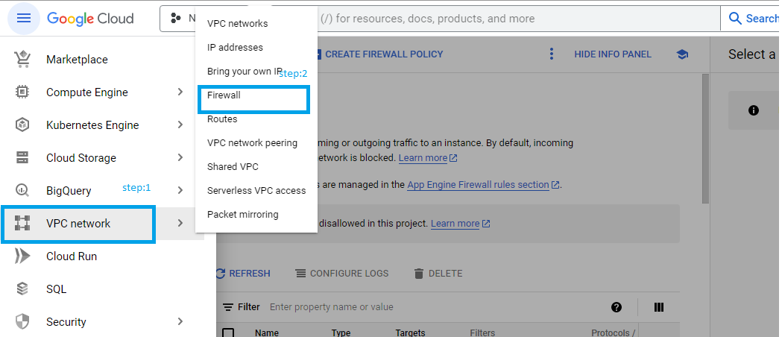

Step: 3 click the 3 dot or click hide info panel to find the create firewall rule

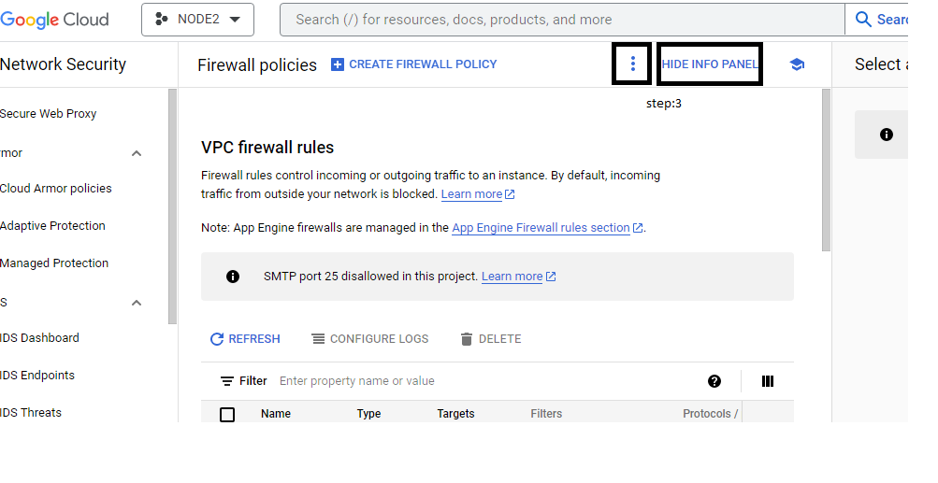

Step: 4 click firewall rule to create the new rule

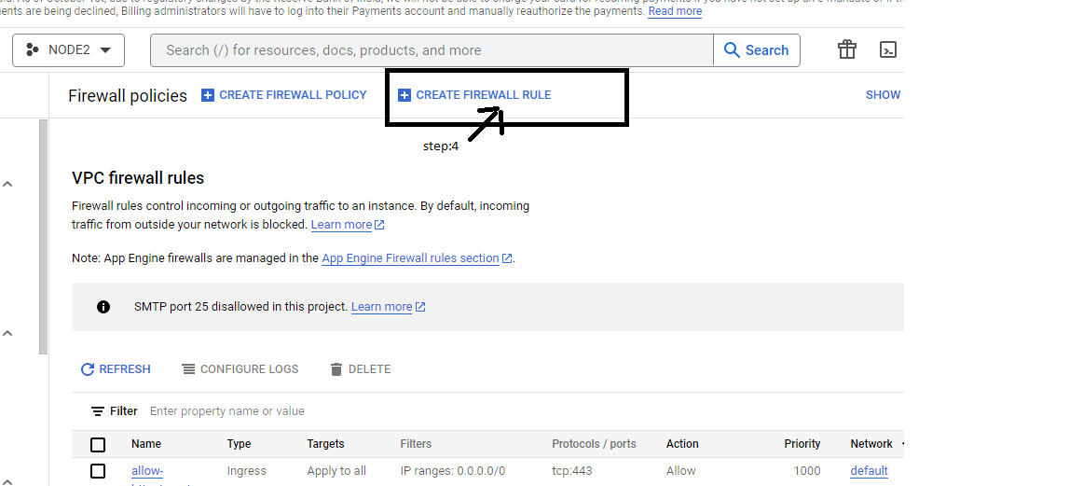

Step: 5 rule name and description need to enter

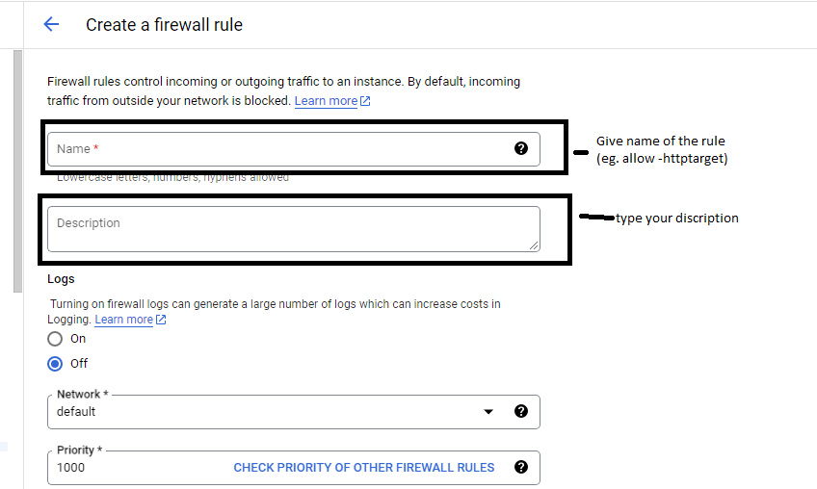

Step: 6 select the all instance in the network

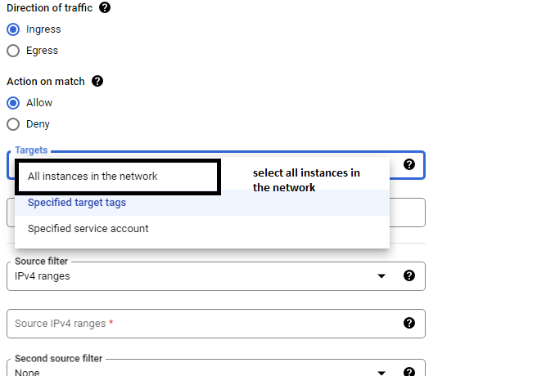

Step: 7 put the ip is 0.0.0.0/0 and select specified protocol and ports

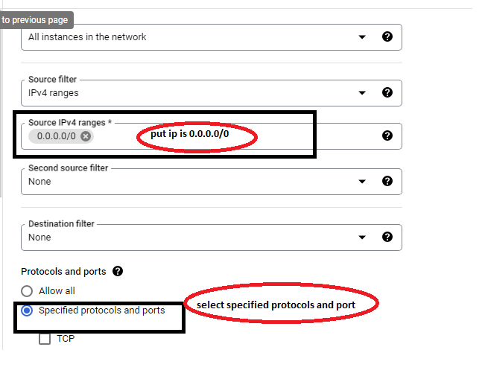

Step: 8 select Tcp and put port no is 80 and click the create button

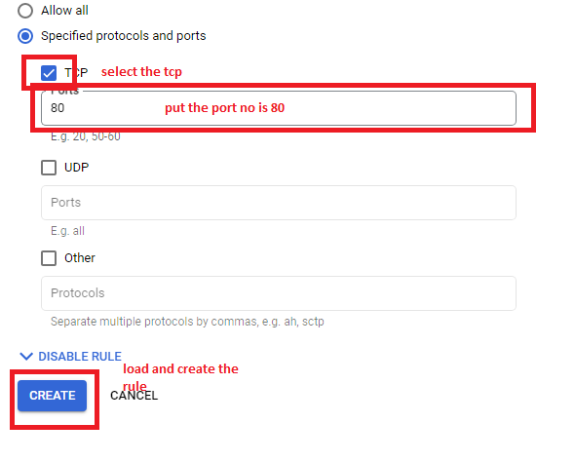

Step:9 check vm instance and click to activate the firewall rule

